**Restaurant Super User Requirement Document**

**Login Page:**

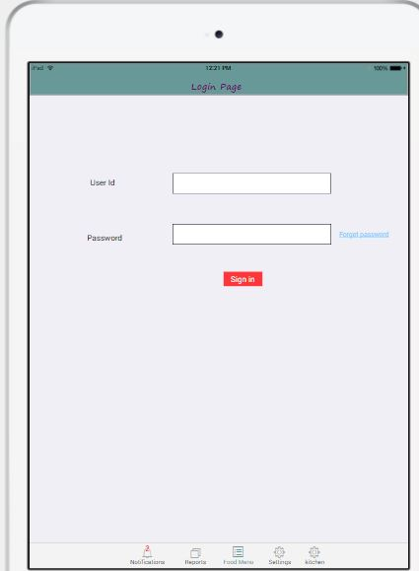

* Login credentials provided by bring meals.
* Forget password link should be sent via otp or mail

**Main Menu:**

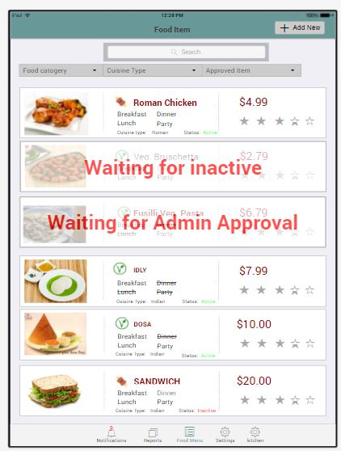

* Main menu is to be show the menu items , search options and filter options.
* Inactive shortcut should be in particular food in main menu

**Add New item:**

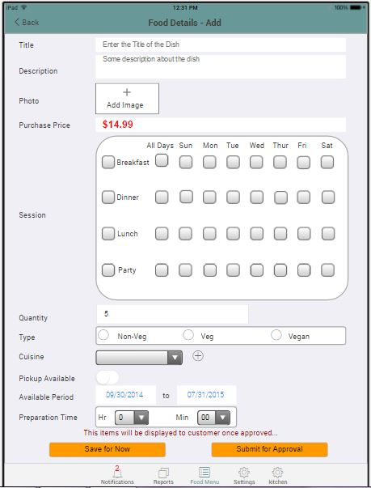

**Edit Food Item:**

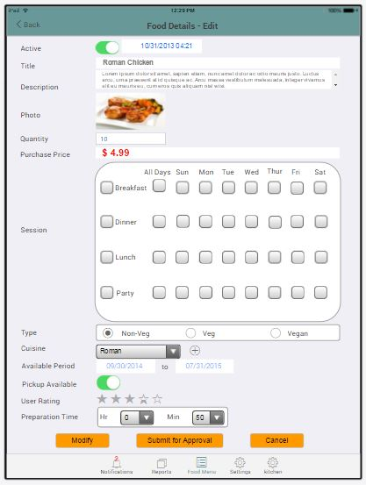

**Notification:**

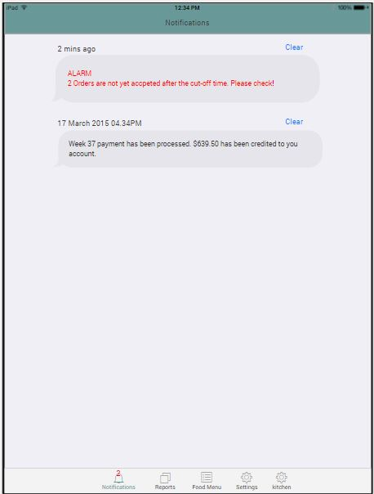

**Reports:**

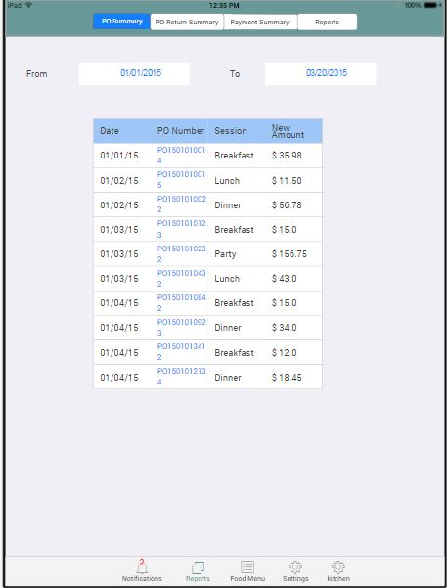

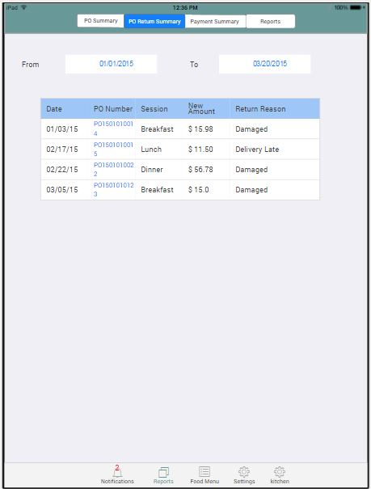

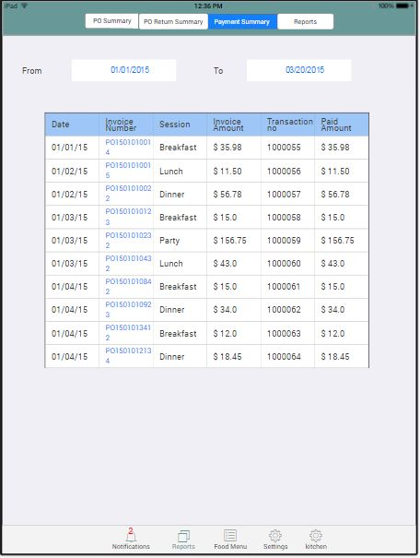

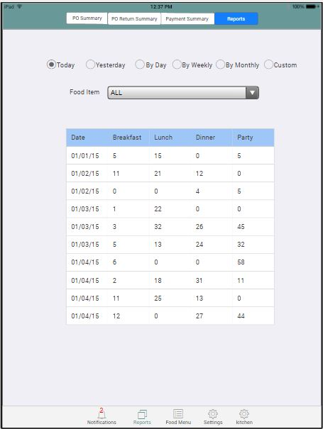

**Settings:**

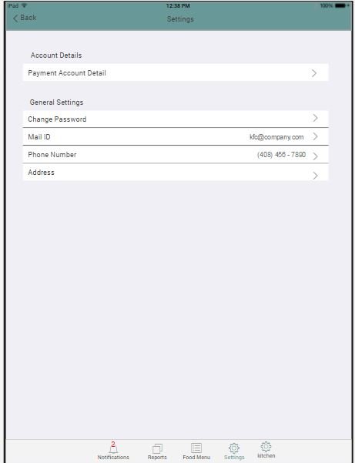

**Payment account details:**

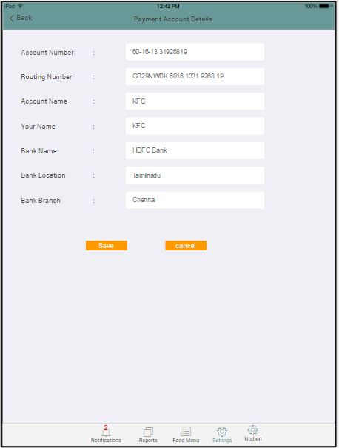

**Address details:**

